|  |  |
| --- | --- |
| Anotherlol  MemePage | Site THeme  Online platform and social media website. Mostly about sharing internet memes(funny pictures and collages). Martin Grigorov, Stoyan Petrov  WEB1 |

**Site Description** – This site is an online platform and social media website. Mostly about sharing internet memes(funny pictures and collages). Visitors have a wide variety of fun pictures and collages to chose from, divided to six categories: Old, Most liked, New Mames(daily), Animal related, car related and people’s behavior related.

We chose this topic, not because there is not enough of those pages, but because they are all different, having different we think there is always room for one more

**Target audience** – Meme lovers and people wanting to spend an hour browsing through funny pictures and collages. Ages from 15 to 30 will find our contend interesting and well thought. By the same token those people will find our page valuable, although others(ages before 15 and after 30) will not quite get our content and they will not like and often visit our page. We have no requirements for our visitors, everyone can join with a simple registration. The registration consist of full name, email, username, password and small description(optional).

**Sitemap:**

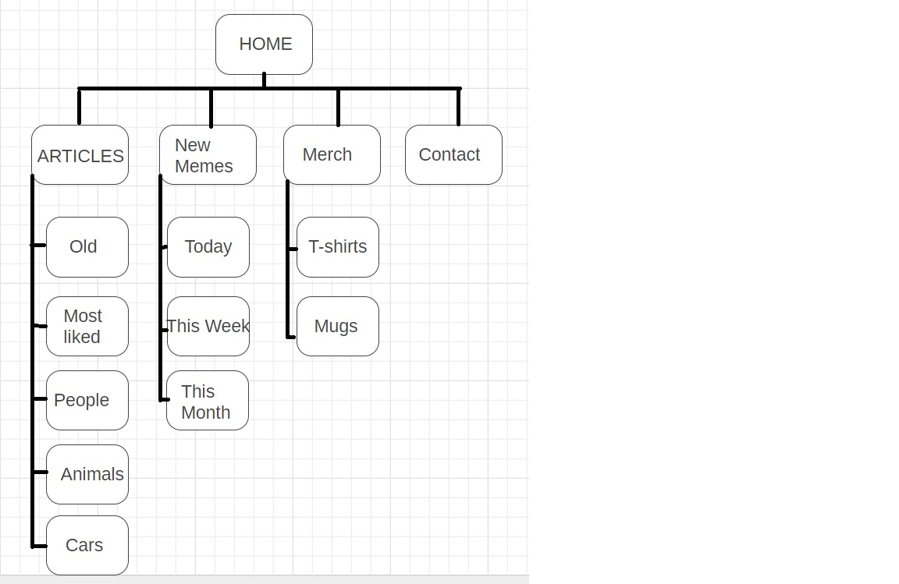

**Wireframe:**

Home page:

Almost all of our pages share this design(Animal related page, old memes page, car related page, new memes page, people related page and most liked memes page)

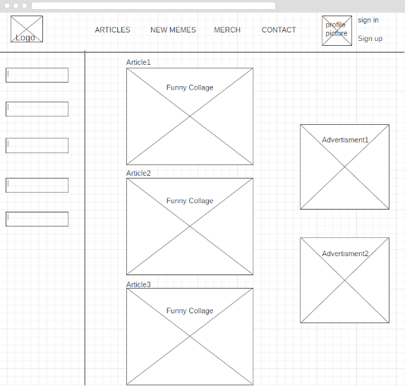

Articles page:

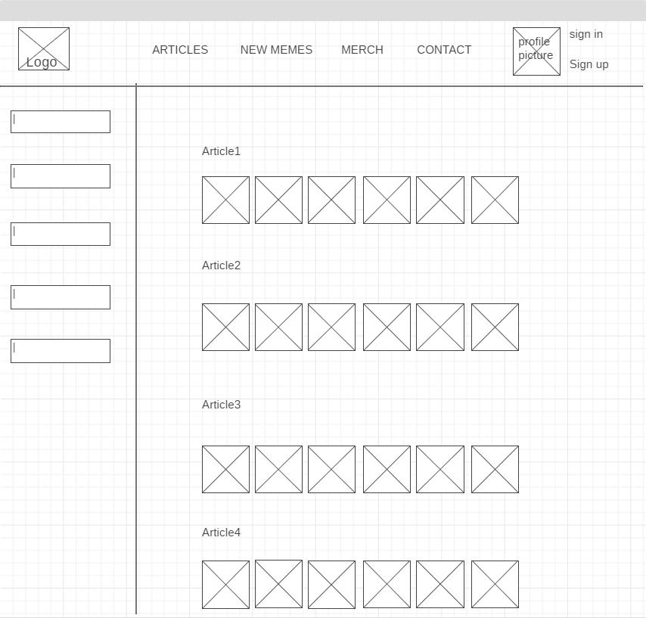

Contact page:

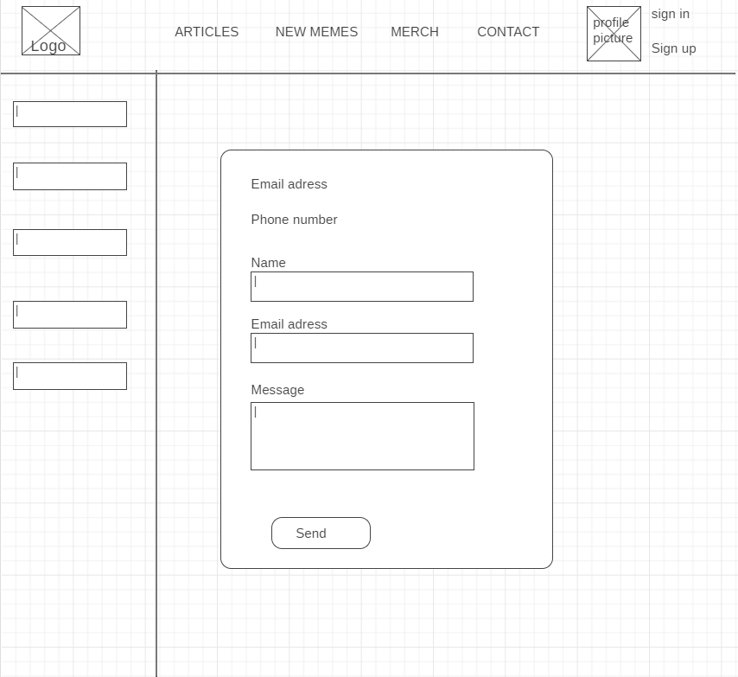

Merchandise page:

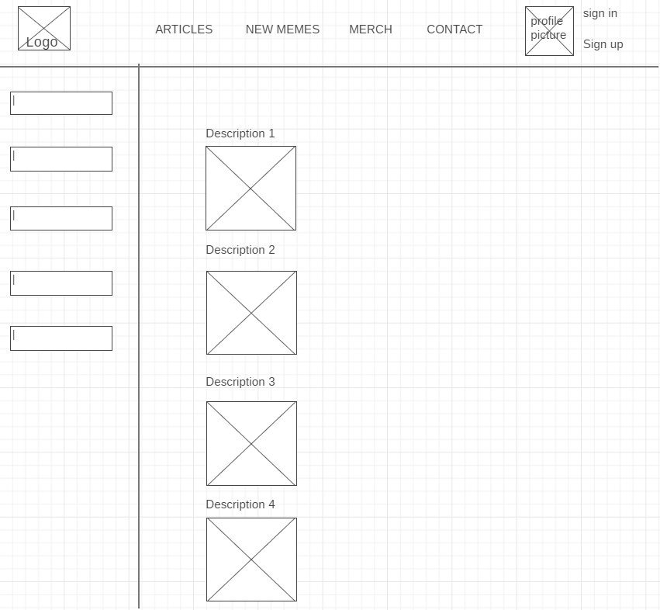

Sign In page:

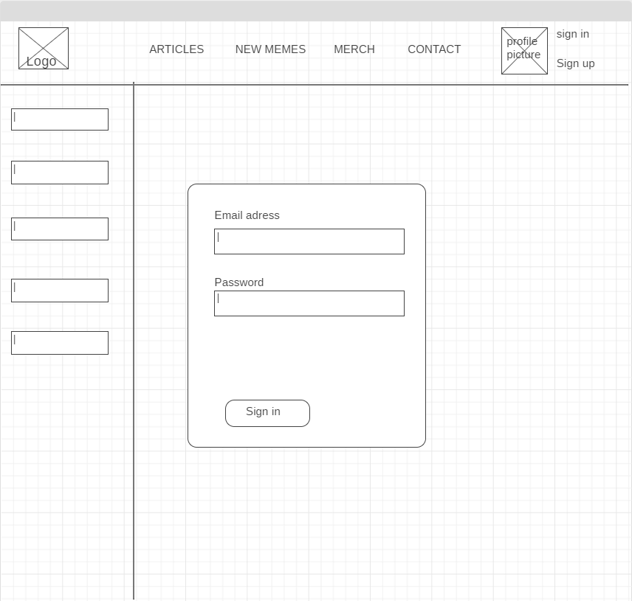

Sign Up page:

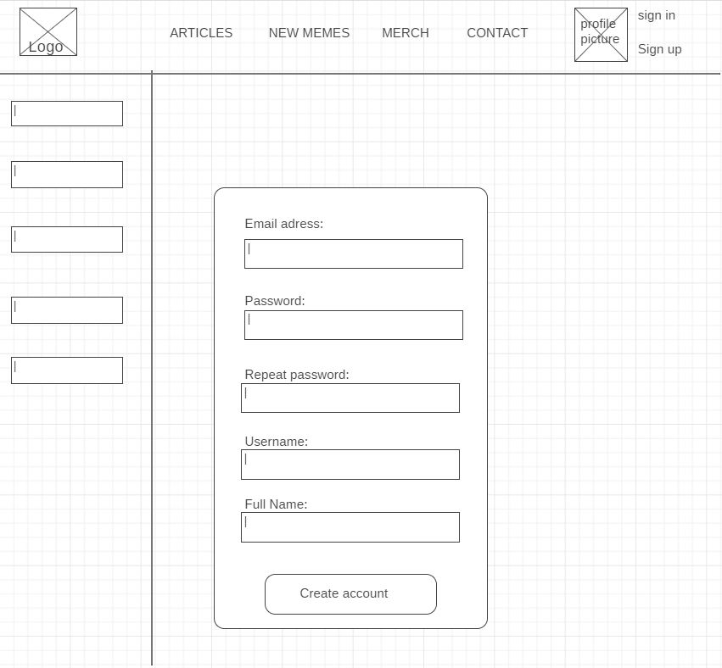

Visual design:

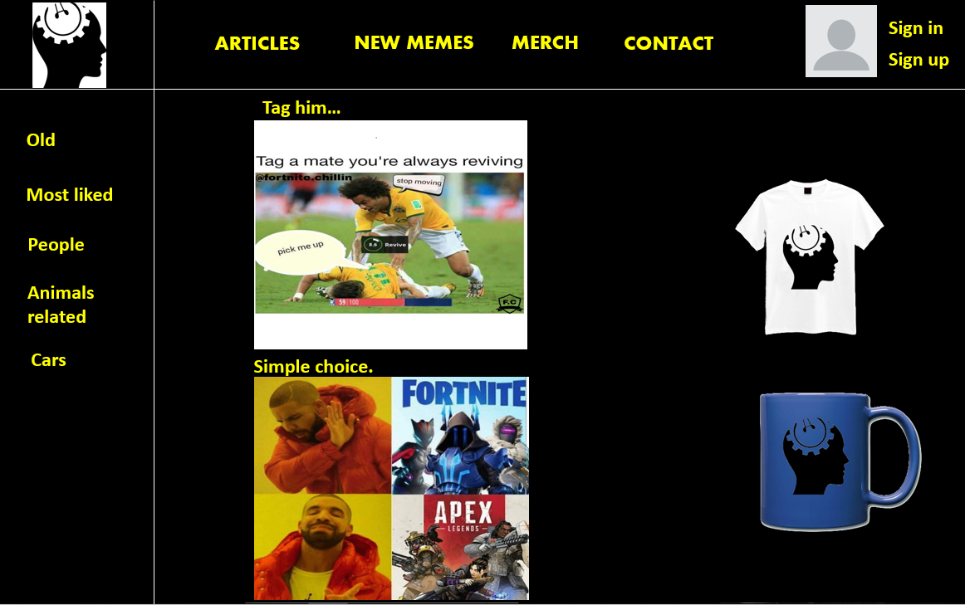

1: Home page

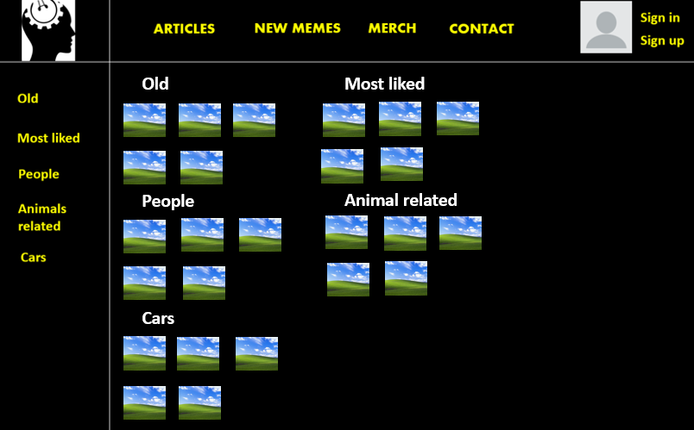2: Articles

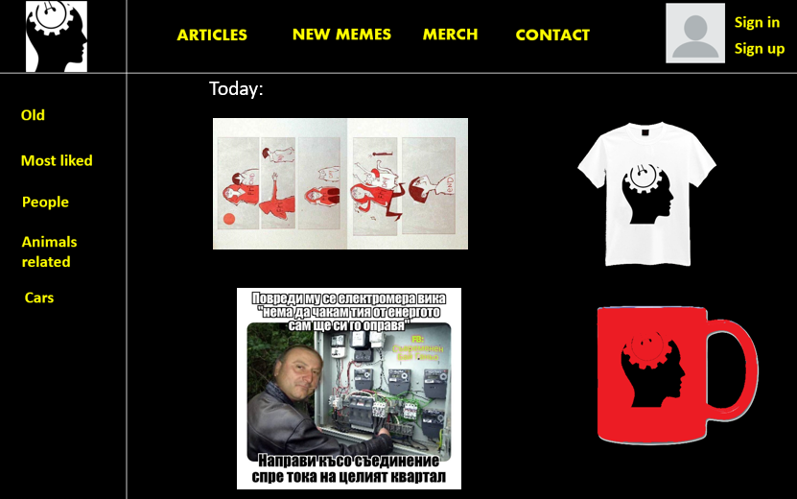

3: New Memes

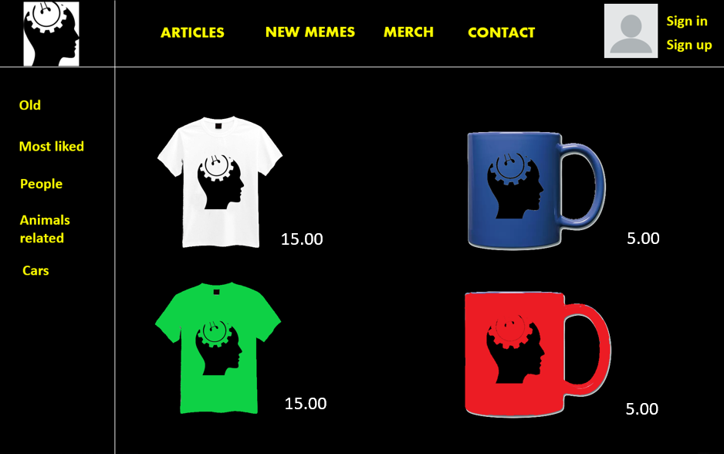

4: Merch

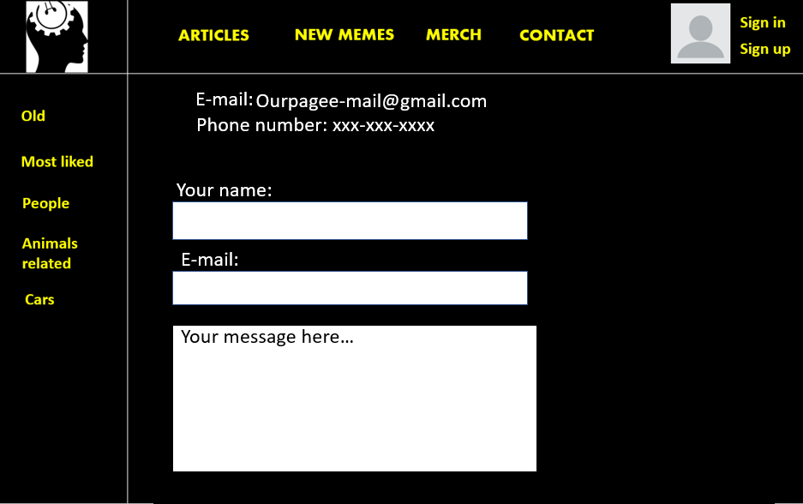

5: Contact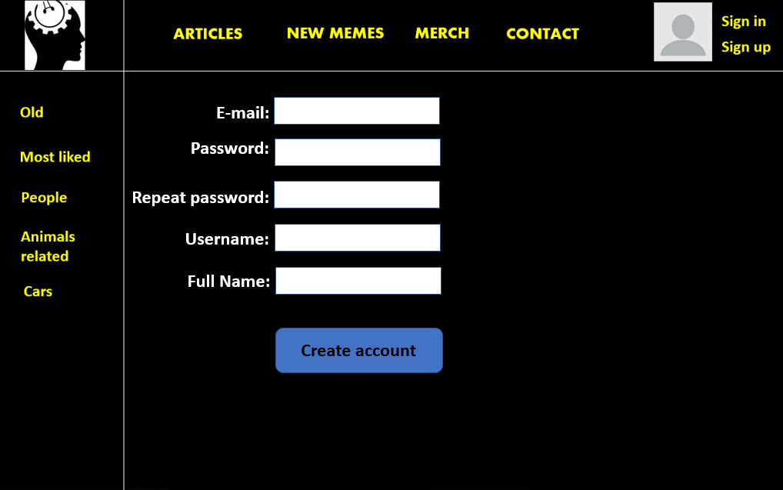

6:Subscription page